Images created in docker labs –

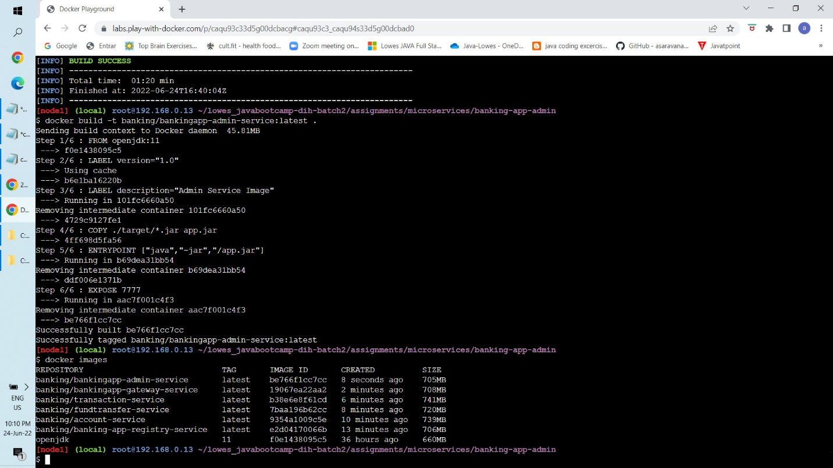

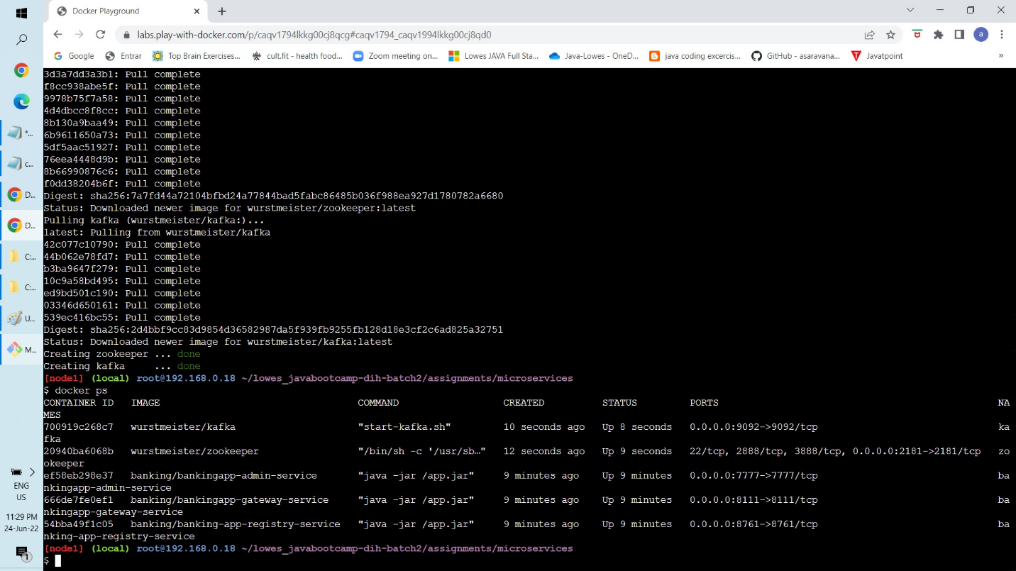Containers created in docker labs

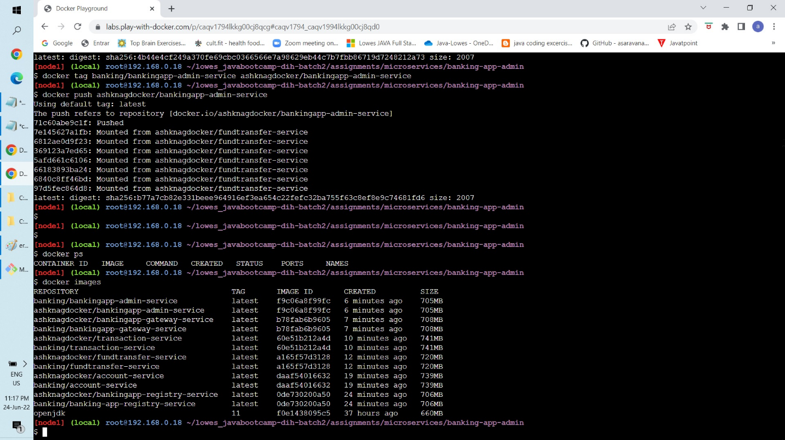Images pushed to docker repository –

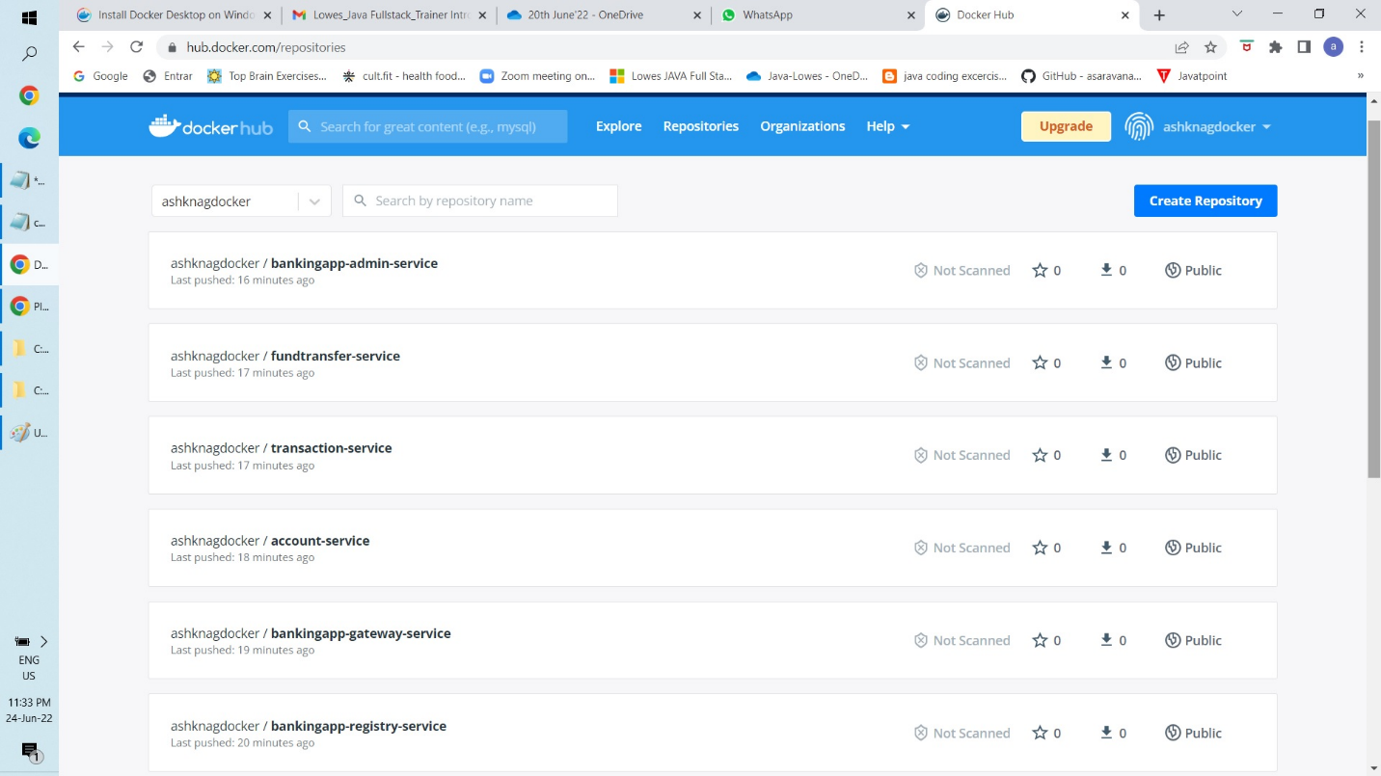

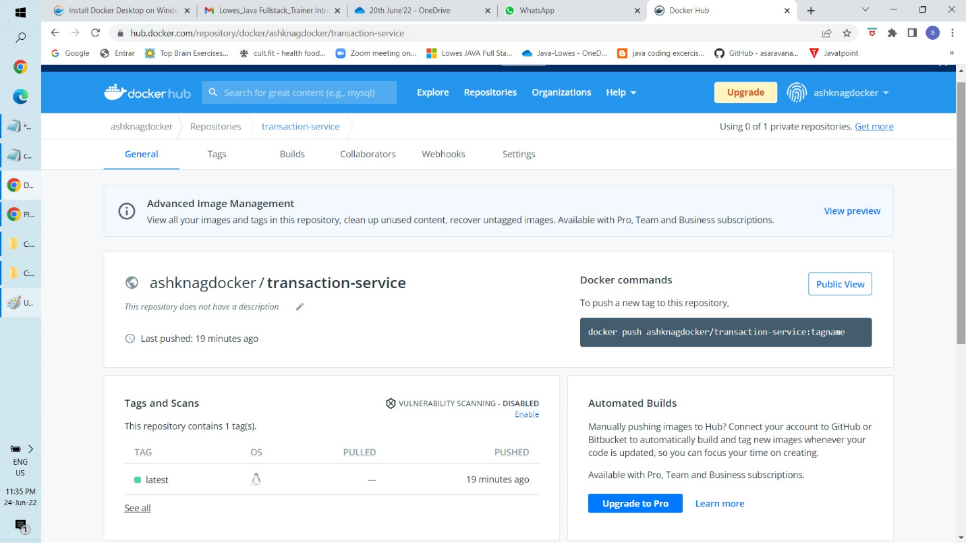

Docker hub -https://hub.docker.com/u/ashknagdocker

Kubernetes Minikube –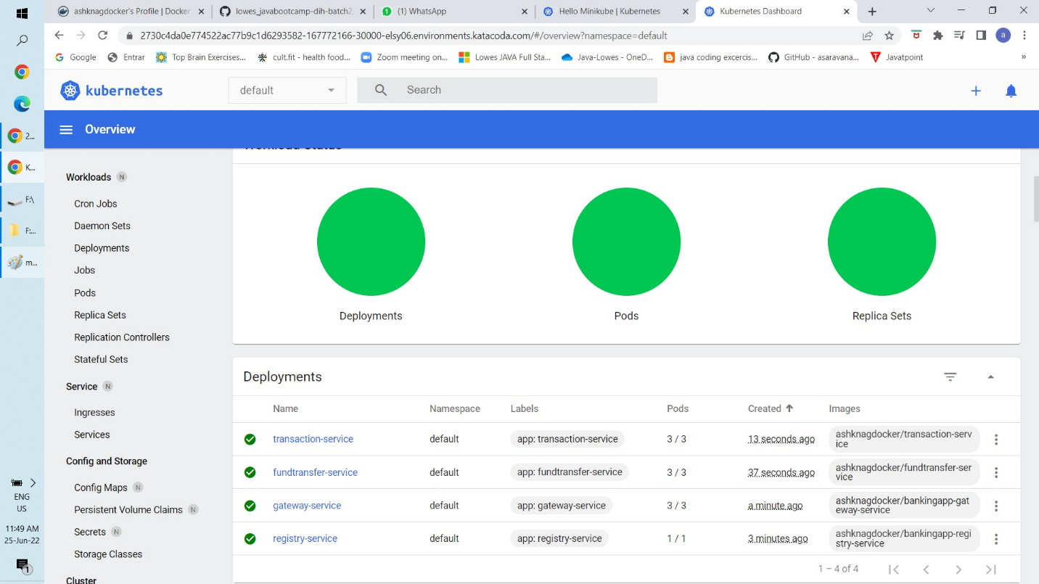

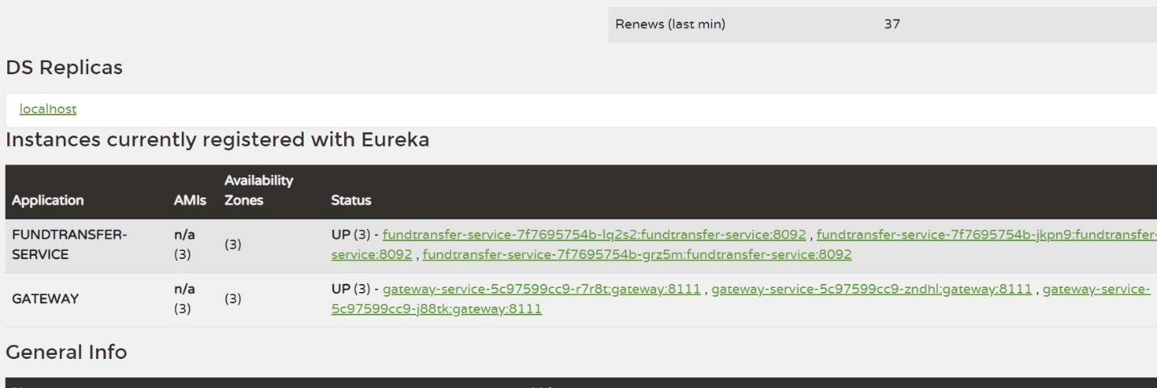

After deploying last service minikube buffers for long time as shown below and later throws error. Same error repeated for 3 times.

